analysis of a game design document

Rush of Service

Courtney adams

Academy of Interactive Entertainment

# HIGH CONCEPT

‘Rush of Service’ is a café management game, where the players must both serve customers and manage their resources to see their café succeed! Players will go through two phases, the day phase, where players will receive multiple orders from their menu and must cook and serve them to their customers, how well they do this impacts their rewards! The ‘night’ phase, has the player gaining ingredients and recipes, updating their menu, customizing their café and viewing their overall café rating.

# TARGET AUDIENCE ANALYSIS

The target audience for ‘Rush of Service’ focuses around those who prefer to play their games whilst on the move to pass the time quickly as well as those who enjoy a management style approach to games.

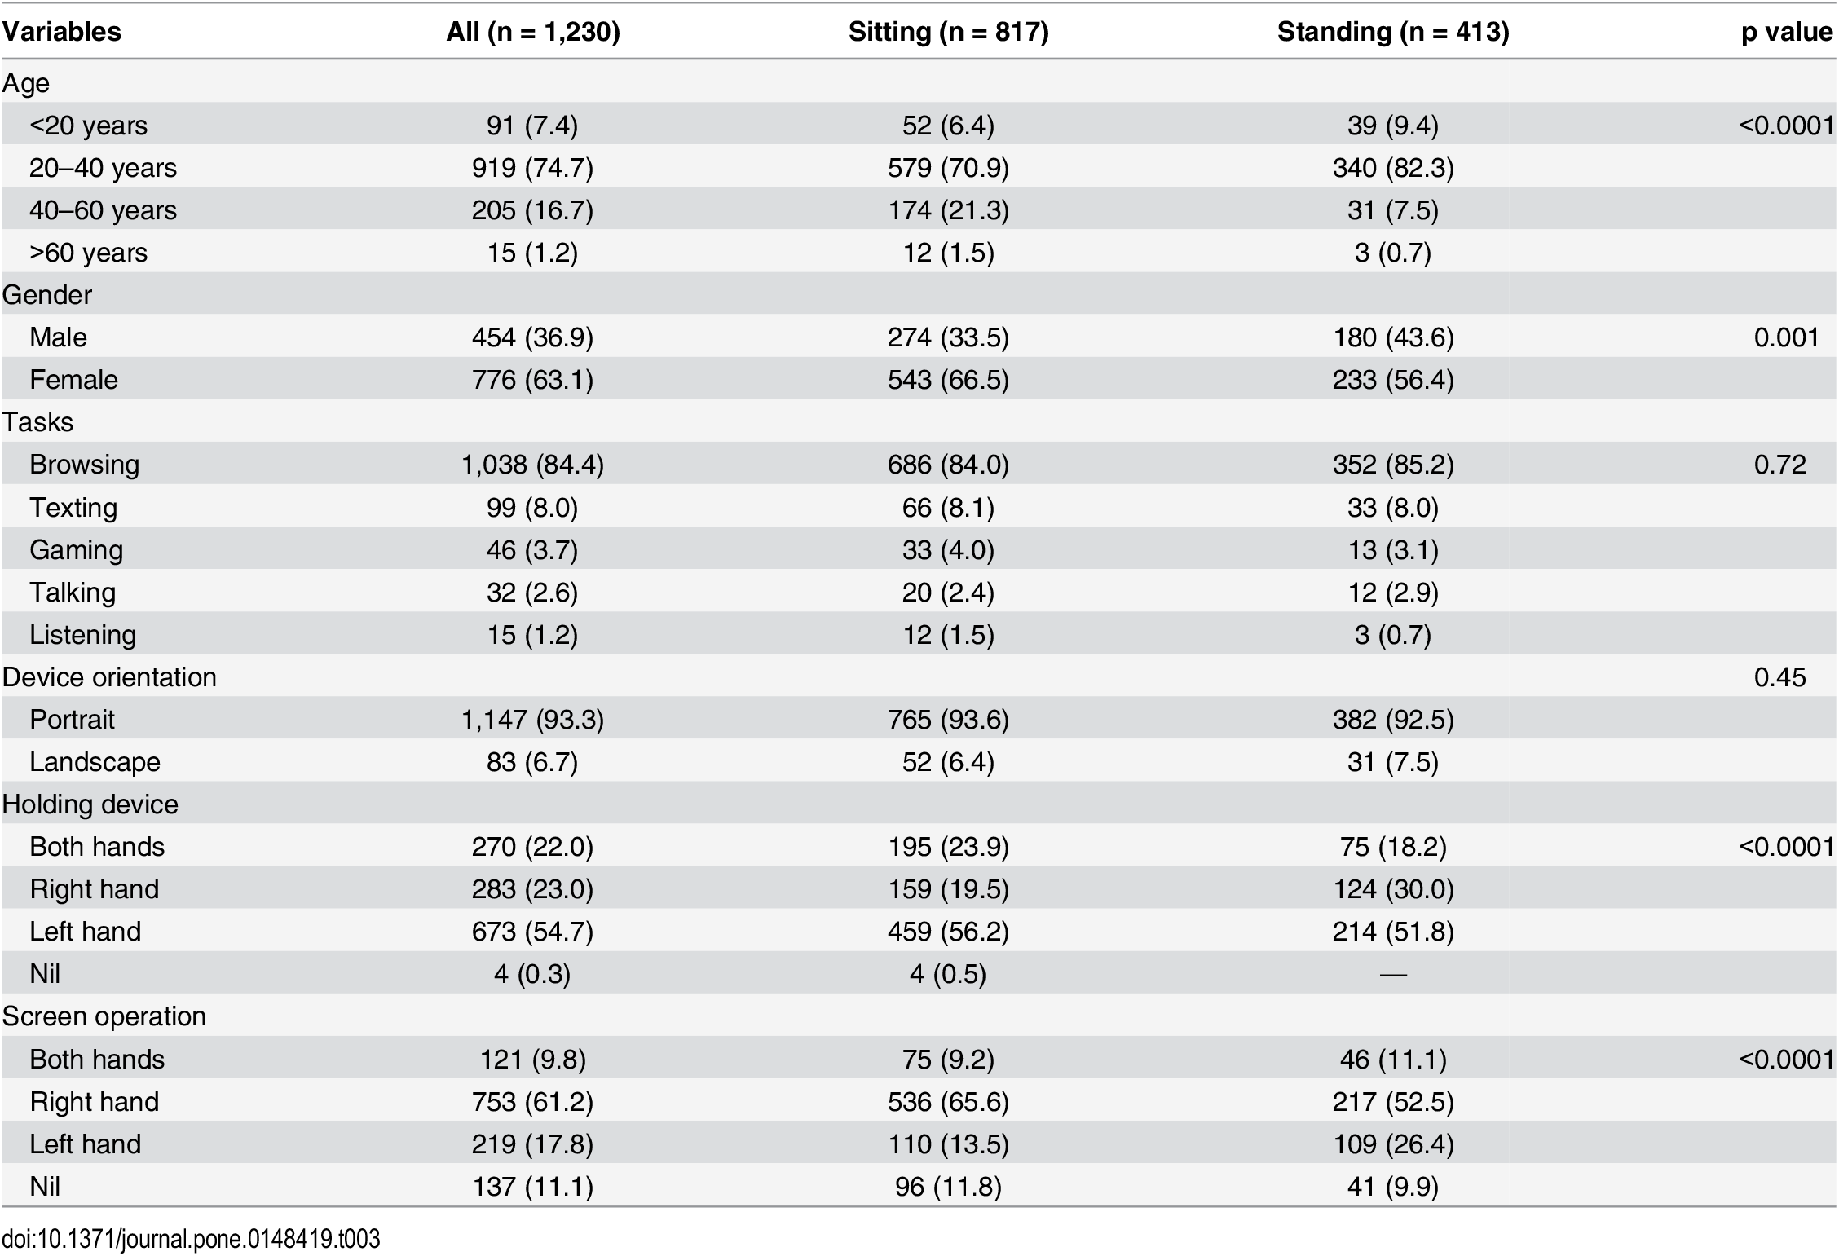‘Rush of Service’ aims to satisfy this target audience through its platform, focusing on mobile devices as well as the Nintendo Switch. These platforms are portable for players and can be played practically anywhere.

In a study conducted in 2016 by Liang H-W, he studied the posture and type of mobile phone was whilst passengers travel on trains. It was discovered that 41% of the total passengers where using their mobile phones, 84% of which was active use (browsing, gaming etc.).[1]

In this test, 3.7% of people were gaming across a spread of both male and female. This is the highest result other than browsing (84.4%) and texting (8.0%).

Overall, mobile phone production rose from 450 million per year in 2011 to 984 million per year in 2013. More than 50% of the population in many western countries own mobile phones.

Another study conducted in the United Kingdom showed that smartphones are now the preferred gaming device for 42% of gamers, the rest being 32% for consoles and 26% for PC.[2]

"More and more people are realizing how fun computer games can be and mobile gaming brings an *element of convenience* that consoles don’t. We’re seeing a whole new audience of players who don’t necessarily identify as gamers at home playing on an expensive console but may instead spend hours on a mobile game that isn’t expensive to buy." - Jason Kingsley OBE, co-founder of independent games developer Rebellion.

Mobile phones, and the Nintendo Switch, which offers the same touch screen approach to gaming, are the most convenient and arguably the cheapest way for people to game today. Having ‘Rush of Service’ based on these devices will tap into a broad market and provide satisfying and strategic gameplay through the game’s mechanics.

# PSYCHOLOGICAL DRIVERS FOR TARGET AUDIENCE

The target audience strives towards convenience, having a gaming device constantly on the go with a broad range of games available. Having mobile phones and the Nintendo Switch strive towards convenience and accessibility, people can game whilst on the go, whether they are travelling short or long distances.

This affects their motivations for playing ‘Rush of Service’ and numerous other games. In particular, ‘Rush of Service’ has a very short, yet rewarding play style that sees players go through two phases. The day phase will be a set time, short enough that someone can play it on a quick bus ride but long enough to have the game feel tense and satisfying to play. If ‘Rush of Service’ required a gameplay loop of thirty minutes, most players will not be able to complete an essential part of the gameplay to receive its rewards and experience the game in its entirety, this is extremely important as the game focuses on two phases.

# FEEDBACK LOOP

Feedback is constantly given to the player throughout the day phase, which gives them an idea as to how they have performed on an overall level. As players serve customers, each customer will give a rating with small yet colourful emoticons which will correspond to their happiness. The end of day phase will then show how much a player has earned for their efforts.

As the player goes through the quick and tense gameplay of the game phase, feedback gives them important information and can offer satisfying reasons to continue playing and see how they performed overall. The end of day phase slows down dramatically, having the player navigate a simple UI and menus that shows their rewards and options for their café.

This is suitable for the target audience because whilst on the go, players can get a satisfying gameplay experience quickly, without putting in numerous hours to receive it.

# MECHANICS REVIEW

The mechanics of ‘Rush of Service’ again, centre around a two-phase day. Players will quickly tap and view customer orders to serve them, allowing a quick and easy feel to the gameplay making the days seem short yet satisfying. The end of day phase still requires on tapping motions but is slowed down massively as players can strategize and manage their café.

This is suitable for the target audience because players can experience two forms of gameplay whilst on the go in a quick manner. They get both a quick, tense and satisfying gameplay experience through the day phase and a slow, strategic and perhaps challenging experience during the end of day phase.

1. https://journals.plos.org/plosone/article?id=10.1371/journal.pone.0148419
2. https://www.forbes.com/sites/annatobin/2018/10/11/is-mobile-phone-gaming-taking-over-from-console-gaming/#68e262c76da3